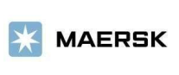

(12/05/2021)

Dear Customer:

Ref: National strike.

As we have been reporting, we are closely monitoring the public order situation facing our country. We continue to serve our clients, with an emphasis on protecting our collaborators (direct and indirect). That is why we want you to know that we have all our service channels available, as follows:

1. Our maritime and terminal services continue operating normally, any change in our service you can consult through our website https://www.maersk.com/ you must activate the subscriptions to receive the information automatically.

2. Due to the blockage in the main roads of the country, the entry and exit of cargo from the main port terminals have been highly affected. Please note that once the roads return to normal, customers must add enough time in their supply chains for the start-up period after port facilities work interruption to return to production levels and eliminate any terminal congestion.

3. The return and assignment of empty equipment at the country interior depots is maintained in the following schedules and in accordance with the agreed reception conditions. Please check with our customer service team co.import@maersk.com in case you have any questions regarding the availability of reception and delivery in each terminal or depot.

We receive the document “*Comodato*” virtually and the allocation or return process with each yard is maintained without any change:

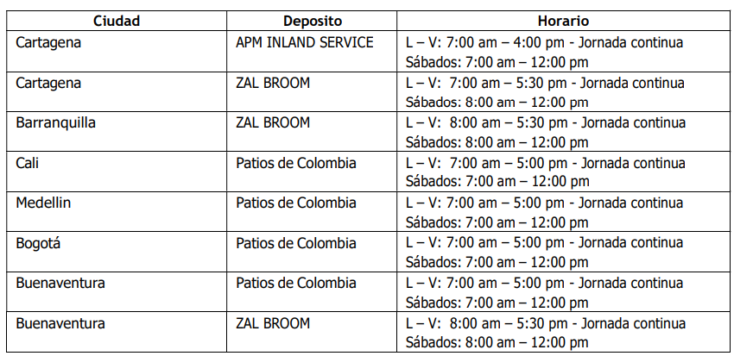

*Subject to changes in schedules, according to security measures*

4. The Counters (Gerleinco Offices) have enabled the Virtual Release process to facilitate the processes of your officials and the COVID-19 contingency release processes are maintained. To expand details, you can consult in: https://sway.office.com/bTTHIUHuPUjFbnbM?ref=email

All branches on a continuous shift,

Saturday from 9am - 12:00 pm.

Cartagena 8:00 AM - 5:00 PM

Buenaventura 8:00 AM - 5:00 PM

Barranquilla 8:00 AM - 5:00 PM

Santa Marta 8:00 AM - 5:00 PM

*Subject to changes in schedules, according to security measures*

5. Land logistics services situation:

a. On 12/05/2021 are convocated to national strike.

b. Buenaventura and Cali continue with blocked, especially in Loboguerrero and Buga, registering fuel shortage.

c. In Cartagena, are scheduled cargo caravans to the interior of the country continues and begins to register vehicle shortage, in San Alberto and Aguachica blockages are projected today.

d. Vehicles with export cargo that are in route to Buenaventura and vehicles with containers in import from this port that have not been able to continue with their transit to the interior of the country due to blockages, they will stop until everything returns to normal and they will continue the transit once the conditions of security are given.

e. In Bogotá, blockades are announced at different strategic points in the city, especially in the afternoon.

f. The same way; We inform that the DIAN has already issued an order of suspension of terms, for presentation of OTM’s through the port of Buenaventura. The Cartagena section continues to operate normally and without cars.

g. Consideration should be given that the following situations may arise:

i. Shortage of vehicles and delays in the withdraw of containers.

ii. Containers stuck, which generates delays in making appointments at the terminals.

iii. Generation of additional costs for warehousing, delays and other concepts; which will not be assumed by Maersk Logistics & Services LTDA.

Additionally, we would like to share with you some important points to be considered in this case:

- Maersk is aware of the delays and inconveniences that stoppages, protests or demonstrations can generate. both for you as clients and for our Company.

- Maersk understands that the strike is beyond the control of the client; however, both the offer and the terms and conditions that govern the transport operation, which are public and can be found in https://terms.maersk.com/ regulate what is related to situations of stoppages / strikes.

- We remain attentive to the situation to inform you of progress.

**We would like to take this opportunity to thank you for doing business with us.**

Any questions or additional queries we are here to serve you.

**Customer Experience Team**